**Group members: Jamal Bonheur, Leonel Ponce, Dante Galvan, Malachi Uzowihe, Kartik Negi**

**Project Plan**

Scope <pg 1 - 2>

Schedule <pg 2-7>

Team Organization <pg 7>

Team Roles: <pg 7>

Resumes: <pg 8-12>

Technical Description <pg 13-14>

Data Management Plan <pg 14-15>

Test Plan <pg 15-16>

**Scope**

1.  Customer Record

* Customer login
  + Name, Email, Address, Phone number, ID
* Create Customer table
* Order tracking and Order history
* Create labels and buttons as well as user input fields for login screen

2.  Streamlined Order Processing

* Order details/attributes
  + Order ID, Customer ID, Product ID, Shipping Address, Link to customer record, Purchase date, payment method
* Create an ER diagram
* Create the order table

3. Customer management

* Define the attributes of the customer
* Create an ER diagram
* Create the customer table
* Include the capability to update customer information

4. Route Determination

* Define the attributes of the route object:
  + Truck ID, Department location, Destination location
  + Product ID, estimated delivery time
* Create an ER diagram
* Create the route table
* Include the ability to update the route information

5. User Interface

* Create Login Screen:  
  1. Username/Password/Email Field  
  2. Login button
* Create Opening Screen  
  1. Brand Logo/ welcome message  
  2. Login button
* Create Selection Screen:  
  1. Navigation menu/buttons for selections and back button  
  2. Customer screen

**Schedule**  < use a work breakdown structure to layout the project tasks, start/finish, planned/actual and status >

| Task ID | Work breakdown structure | Planned start | Planned finish | Workload-planned | Workload - actual | Progress (%complete) |
| --- | --- | --- | --- | --- | --- | --- |
| 1 | Customer Record | 6/17 | 7/13 | 17 hrs |  |  |
| 1_1 | login | 6/17 | 7/8 | 2 hrs |  |  |
| 1_1_1 | customer details | 6/17 | 7/8 | 1 hr |  |  |
| 1_2 | customer table | 6/17 | 7/13 | 4 hrs |  |  |
| 1_3 | tracking and history | 6/17 | 7/8 | 5 hrs |  |  |
| 1_4 | labels and buttons | 6/17 | 7/8 | 5 hrs |  |  |
| 2 | Streamlined Order Processing | 6/17 | 7/13 | 10 hrs |  |  |
| 2_1 | Order details/attributes | 6/17 | 6/25 | 2 hrs |  |  |
| 2_2 | Create ER diagram | 6/17 | 6/19 | 1 hr |  |  |
| 2_3 | Create order table | 6/17 | 7/13 | 7 hrs |  |  |
| 3 | Customer management | 6/17 | 7/8 | 9 hrs |  |  |
| 3_1 | define customer attributes | 6/17 | 6/18 | 2 hrs |  |  |
| 3_2 | Create ER diagram | 6/25 | 6/26 | 1 hr |  |  |
| 3_3 | Create customer table | 6/25 | 7/2 | 4 hrs |  |  |
| 3_4 | update customer info | 6/25 | 7/3 | 2 hrs |  |  |
| 4 | Route Determination | 6/25 | 7/8 | 11 hrs |  |  |
| 4_1 | Define route attributes | 6/25 | 7/14 | 2 hrs |  |  |
| 4_1_2 | Implement attributes | 6/26 | 7/8 | 2 hrs |  |  |
| 4_2 | Create an ER diagram | 6/26 | 6/27 | 1 hr |  |  |
| 4_3 | Create route table | 6/26 | 7/8 | 2 hrs |  |  |
| 4_4 | Include route update | 6/26 | 7/14 | 4 hrs |  |  |
| 5 | UI | 6/19 | 7/8 | 17 hrs |  |  |
| 5_1 | Create Login | 6/19 | 6/27 | 5 hrs |  |  |
| 5_1_1 | Information Fields | 6/19 | 6/22 | 4 hrs |  |  |
| 5_1_2 | login button | 6/19 | 6/20 | 1 hr |  |  |
| 5_2 | Create Opening | 6/22 | 6/24 | 3 hrs |  |  |
| 5_2_1 | Brand/welcome labels | 6/22 | 6/23 | 2 hrs |  |  |
| 5_2_2 | Login button | 6/23 | 6/24 | 1 hr |  |  |
| 5_3 | Create Selection Screen | 6/24 | 7/8 | 10 hrs |  |  |
| 5_3_1 | Nav menu/buttons | 6/24 | 6/30 | 5 hrs |  |  |
| 5_3_2 | Customer Screen | 6/30 | 7/8 | 5 hrs |  |  |

## **Gantt Chart:**

| Task ID | Title | 6/22 | 6/29 | 7/3 | 7/8 | 7/10 | 7/13 | 7/17 | 7/20 | 7/24 |
| --- | --- | --- | --- | --- | --- | --- | --- | --- | --- | --- |
| 1 | Customer Record |  |  |  |  |  |  |  |  |  |
| 1_1 | login |  |  |  |  |  |  |  |  |  |
| 1_1_1 | customer details |  |  |  |  |  |  |  |  |  |
| 1_2 | customer table |  |  |  |  |  |  |  |  |  |
| 1_3 | tracking and history |  |  |  |  |  |  |  |  |  |
| 1_4 | labels and buttons |  |  |  |  |  |  |  |  |  |
| 2 | Streamlined Order Processing |  |  |  |  |  |  |  |  |  |
| 2_1 | Order details/attributes |  |  |  |  |  |  |  |  |  |
| 2_2 | Create ER diagram |  |  |  |  |  |  |  |  |  |
| 2_3 | Create order table |  |  |  |  |  |  |  |  |  |
| 3 | Customer management |  |  |  |  |  |  |  |  |  |
| 3_1 | define customer attributes |  |  |  |  |  |  |  |  |  |
| 3_2 | Create ER diagram |  |  |  |  |  |  |  |  |  |
| 3_3 | Create customer table |  |  |  |  |  |  |  |  |  |
| 3_4 | update customer info |  |  |  |  |  |  |  |  |  |
| 4 | Route Determination |  |  |  |  |  |  |  |  |  |
| 4_1 | Define route attributes |  |  |  |  |  |  |  |  |  |
| 4_1_2 | Implement attributes |  |  |  |  |  |  |  |  |  |
| 4_2 | Create an ER diagram |  |  |  |  |  |  |  |  |  |
| 4_3 | Create route table |  |  |  |  |  |  |  |  |  |
| 4_4 | Include route update |  |  |  |  |  |  |  |  |  |
| 5 | UI |  |  |  |  |  |  |  |  |  |
| 5_1 | Create Login |  |  |  |  |  |  |  |  |  |
| 5_1_1 | Information Fields |  |  |  |  |  |  |  |  |  |
| 5_1_2 | login button |  |  |  |  |  |  |  |  |  |
| 5_2 | Create Opening |  |  |  |  |  |  |  |  |  |
| 5_2_1 | Brand/welcome labels |  |  |  |  |  |  |  |  |  |
| 5_2_2 | Login button |  |  |  |  |  |  |  |  |  |
| 5_3 | Create Selection Screen |  |  |  |  |  |  |  |  |  |
| 5_3_1 | Nav menu/buttons |  |  |  |  |  |  |  |  |  |
| 5_3_2 | Customer Screen |  |  |  |  |  |  |  |  |  |

**Team Organization**

Team Roles :

Dante: GUIs, frontend engineer

Leonel: GUIs, frontend engineer

Jamal: Data Handling / project manager

Malachi: Classes/Objects, backend engineer

Kartik: Specified classes and methods for sales reps, backend engineer

**Resumes**

**Malachi Uzowihe**

Marietta, GA | 6786001006

uzowihemalachi@gmail.com

**Experience**

Kroger | GA, Marietta

Courtesy Clerk | 07/2022 ~~-~~ 08/2022

I was responsible for organizing the shopping carts, bagging groceries, assisting customers and coworkers/managers, cleaning up messes and ensuring that the customer's shopping experience was enjoyable.

**Skills**

Customer service, Computer literacy, Time management, Communication skills, Adaptability, Critical Thinking, Writing Skills, Cooperative, Collaboration

**Education**

Kennesaw State University | Marietta, GA

Software Engineering | 05/2026

Currently pursuing Software Engineering Degree

Completed Computer Science Problem Solving I, Computer Science Problem Solving II

Taking Intro to Software

Osborne High School | Marietta, GA

High School Diploma | 05/2022

Played the position of Wide Receiver/Linebacker on the school football team from 2018 to 2022

Completed 3DE

**Achievements**

Recipient of Hope Scholarship

Graduated with Honors

Dante Galvan

[dante.galvan2004@gmail.com](mailto:dante.galvan2004@gmail.com) | (678)-330-6940 | [LinkedIn](http://www.linkedin.com/in/dante-galvan-038a54279) | Atlanta, Ga | (ENG/ESP)

# 

# EDUCATION

**Kennesaw State University** | *B.S. Software Engineering, Finance Minor* | Kennesaw, Ga.

Relevant coursework: *ECON 1000: Contemporary Economic Issues, COMM 1100: Human Communication, CSE 1322: Program Problem Solving II, STAT 2332: Probability and Data Analysis*

# EXPERIENCE

Expected Graduation: May 2026

Cumulative GPA: 3.89



**Dependable Painting |** *Laborer |* Dallas, Ga Jun. 2021 – Present

* Worked on residential projects ranging from remodeling to repairs
* Would be able to perform various jobs such as siding, drywall, painting, etc. with quickness and efficiency
* Handled and delivered materials to the jobsite while accounting for the company’s budget on the job
* Would assist in creating invoices to present to the customers

**Virtue Valet** | *Lot Manager* | Marietta, GA Nov. 2023 - Present

* Greet and consult visitors about the valet services at different establishments, organized the lot to maximize the limited space
* Ensured customers vehicles and belongings were safe and accounted for
* Collected and handled the tips to ensure they were fairly distributed amongst my coworkers

# EXTRACURRICULARS & PROJECTS

**MATLAB truss analyzer**

* Created a MATLAB program that a user can enter in the plot points of a truss diagram
* Using the dimensions of the user-input truss the program was able to calculate the angles between each member of the truss.
* The program used linear algebra to find the moments and the forces in each member of the truss

**KSU 13th annual pumpkin launch** | *3rd place recipient*

* An event held every year as part of a tradition where teams construct a mechanism with limited budget to launch a pumpkin the furthest in a fun community competition
* Completed a well-built sturdy trebuchet under a tight schedule and budget
* Performed on site emergency revisions/repairs day of the competition and secured third place

**Java Connect Four game**

* Created a connect four playable game in java using OOP principles
* Game could be saved using fileIO

**Arduino works**

* Using python, made various mini projects with the Arduino and its components provided by the manuals
* Projects include creating a digital sign that could display user-input messages, programming a joystick, creating a light display, etc.

# SERVICE

**Hands on Atlanta** | *Volunteer*

* Volunteered to assist a local elementary school in carrying out the discovery program from Hand on Atlanta
* Would take care of a classroom of students and assist the teacher in carrying out the daily activities
* Engaged the students in learning about STEAM and provided help to students who needed more help

**Lifeteen** | *Volunteer*

* Volunteered in helping teens do their activities and provide guidance or wisdom from my own personal experiences
* Would work with the leader of the organization and help him in organizing events for the teenagers to take part of and have fun in

# ACHIEVEMENTS

Recipient of the Zell miller scholarship Awarded May 2022

Southern Polytechnic College of Computing and Engineering Technology Dean’s list Awarded Dec. 2022, May 2023, & Dec 2023

# NOTABLE SKILLS

Spanish, MATLAB, R, Data Analysis, Java, C++, Microsoft Excel

Leonel Ponce

[Ponceleonel875@gmail.com](mailto:Ponceleonel875@gmail.com) | (404)-247-9138 | [LinkedIn](https://www.linkedin.com/in/leonel-ponce-33bbb5253/) | Atlanta, Ga

# 

# EDUCATION

**Kennesaw State University** | *B.S. Computer Science* | Kennesaw, Ga.

Relevant coursework: *CSE 1322: Program Problem Solving II, MATH 2345 Discrete Mathematics*

# EXPERIENCE

Expected Graduation: May 2026

Cumulative GPA: 3.55



**El Super Pan |** *Bartender|* Atlanta, Ga Jan. 2024 – Present

* Deliver exceptional customer service
* Wide variety of cocktail knowledge, adhering to recipes and customer preferences
* Manage inventory, completing daily batch counts
* Prep and stock, prep citrus, backup batches, keg checks, paper goods, glassware, etc.
* Maintain cleanliness and organization of bar
* Handle cash transactions accurately
* Collaborated with the waitstaff and kitchen team to provide seamless service during peak hours

**El Super Pan** | *Various Roles* | Atlanta, GA Dec. 2021 - Jan. 2024

* Server
* Bar Back
* Expo
* Food Runner

# ACHIEVEMENTS

Recipient of the Zell miller scholarship Awarded May 2022

Southern Polytechnic College of Computing and Engineering Technology Dean’s list Awarded Dec. 2022, May 2023, & Dec 2023

# NOTABLE SKILLS

* Java
* Phyton
* Spanish
* Photoshop
* Customer Service
* Cash Handling
* Inventory Management
* Multitasking
* Problem-Solving

l

| Jamal Bonheur  **C.S. student**  **AI Club at KSU** | horizontal line Jamal Bonheur Atlanta, GA  404-984-8134  [Jamal.Bonheur20@gmail.com](mailto:Jamal.Bonheur20@gmail.com)  <https://www.linkedin.com/in/jamal-bonheur-b39233205/>  <https://github.com/Pr0gramm3r2022> |
| --- | --- |
| **ㅡ** Skills | horizontal line  Python(Pandas, Numpy, OpenCV, Tensorflow), Java, SQL, AWS, Git and GitHub, Virtual Machines with VirtualBox, Software Troubleshooting, MS Visual Studio 2022, MSSMS, Linux, Shell Scripting with Windows CLI, Powershell, Python Shell, and Bash |
| **ㅡ** Projects | horizontal line  **KSU Innovation Hackathon Fall 2023/ ” FreeSpace”**  September 14th - September 16th, Kennesaw, GA   * Worked on an experimental Python application that determined room occupancy by using OpenCV to utilize computer vision to detect and monitor the flow of people in and out of rooms. * Implemented Python scripts for data collection, analysis, and visualization. * Primarily supported and helped test the code, documented the different stages of the process, and made a PowerPoint presentation to present our findings.  **KSU Hackathon for Social Good Spring 2024/ “PrevAbduct** February 22nd - February 24th, Kennesaw, GA   * Performed Data Analysis on several datasets on child abduction to find correlations to present to the user * Learned basic functions of ECL to query the database and to properly group the data and visualize it as tables for the user * Troubleshooted the ECL IDE during setup to get it running smoothly in a very short amount of time. * Documented the different stages of the process and presented our findings by making a PowerPoint. |
| **ㅡ** Education | horizontal line **Chattahoochee Technical College,** Marietta, GA — *Bachelor of Science in Computer Science*August 2020 - December 2021Took general education courses.**Kennesaw State University,** Kennesaw, GA— *Bachelor of Science in Computer Science*January 2022 - May 2025Took courses in: Programming and Problem Solving 1 and 2Data StructuresIntro to Database SystemsComputer Organization and ArchitectureCloud Software DevelopmentArtificial IntelligenceTechnical Writing  * Probability and Data Analysis |
| **ㅡ** Awards | horizontal line  NSLS Member |

**Technical Description**

**Introduction**

The projected user interface for the new order management system for Acme distributing will be developed using a Windows Forms .NET application. The backend will be implemented in C# ,and SQL will be used for database management. In this description the interfaces the user will interact with, such as the login screen and the selection screen, will be outlined. As well as discuss the development restrictions, design and coding methods. Furthermore, the software and hardware requirements will be specified.

**Opening Screen**

Beginning with the opening screen, it will be the screen presented to the user when the application is first opened. The user interaction of the opening screen will display a logo of Acme beverage company and welcome the user by having a label displaying a friendly welcoming message. Under the welcoming message there will be provided options for what the user would like to do on the application. These options will be buttons that the user can click on to access the appropriate functionality. The following options are, login: will direct the user to the login page, help: will provide the user with the technical description, and exit: will exit and close the application

**Login Screen**

Once the user clicks the login button, they will be presented with the login screen where they can type their credentials to access their accounts specified by labels. The login screen will have fields where the user can enter their username and password. It will also contain a login button for once the user enters their information, the program will verify the credentials by checking the database for the entered information and if valid it will direct the user to the selection screen. If the user wishes to leave the login screen and return to the opening screen there will be a back button that will direct them to the opening screen.

**Selection Screen**

Once logged in the user will be presented the selection screen with a label welcoming the user using their username. Here the user will be provided with options for what they would like to do with the application. These buttons will be provided in a menu where the sales rep can choose to add a customer, update an existing customer's info, or plan a sales route. Admins will have the additional option to add a new sales rep into the database so that they would be able to login to the application. A logout button will also be available which will return the user to the opening screen.

**Customer management**

When a sales rep selects the option to add a customer they will be presented with fields where they can enter the customers information, each field being specified by appropriate labels. Once entered the information will be stored in the database. If the sales rep were to select the option of updating a customer's information they will first be presented with a field where they can enter the customer's name. A label will ask the user to enter the name and a button labeled submit will be at the bottom of it. If the submit button is clicked and it is a valid customer then the same fields used for the adding new customer screen will be presented with the information already filled out. The user can then go ahead and perform any necessary modifications to the customer's information. At the bottom of the fields of the customer information page there will be two buttons. A button to fill out an order and a button to submit the customers information and return to the selection screen.

**Orders/Billing and Inventory Management**

From the customer information screen, if the button to fill out an order is selected then the sales rep will be presented with labeled fields where they can enter the order information such as quantity, price, and type of product. A submit button will finalize the order once clicked, sending the order information to the distribution center, and generate the bill of the lading and invoice saving it into a file for the respective customer/store. Once this occurs the user will be brought back to the selection screen where a panel with the label saying “order successful” will appear. The user can click on the exit button underneath the label that will close out the panel.

**Route Determination**

On the selection screen there will also be an option for route determination on the menu. Once clicked, the sales rep will be able to organize and plan their sales route with a submit and finish button that will finalize their sales route and bring them back to the selection screen.

**Hardware and Software Requirements**

The application will require a minimum of 4GB of ram and at least 1GB of storage. A dual core processor or better and access to the internet. The software requirements are windows 11 and .NET framework. There will also be the necessity of a SQL server 2016 or later for the database server.

**Development Restrictions/ Design and Coding Methods**

Some development restrictions for this application are the security and the performance of the application. As well as time and resources available to complete development.

The tools used are visual studio for developing and testing the application along with the WindowsForms App (.Net Framework) to make the user interface. SQL Server Management Studio will be used to make the SQL database. The design is going to be user friendly and the code is planned to be well structured as well as reusable. Tasks will be split up among the development team to complete the application. A github repository is where the development team will share their completed tasks and build the application. Taking these into account the development team will produce the order management system for Acme Distributing by their deadline.

**Data Management Plan:**

We intend to build a database to store that data we need for Customer management, route determination, and route determination. This will allow us to efficiently store and retrieve the data needed for these processes they need to be executed in the application. We also intend to build in the capability for a user to update the information inside the database when needed. Once the Database is completed, we will connect the database to the GUI so the users can interact with the data in a smooth and efficient way.

ER Diagram:

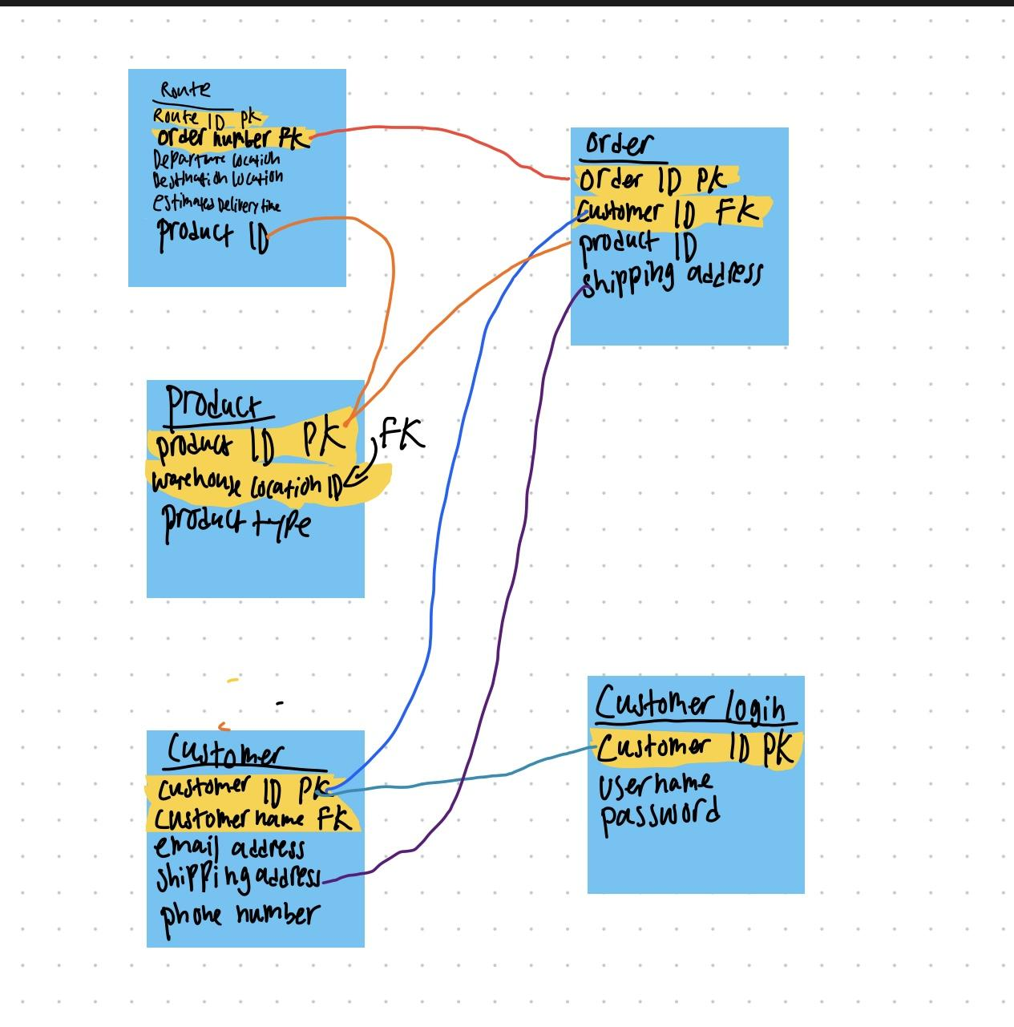

**Test Plan**

Test plan < several paragraphs about: how the application will be tested; what are the criteria for terminating testing; training of users; user testing and automation; paging issues, data storage, and management access are also covered. >

We intend to test the database by writing a series of sample queries to it to make sure that it outputs the correct data when it is requested. For the GUI, we intend to conduct usability testing by asking users to complete a series of tasks using our application, and to

**Frontend Testing**

**Leonel Ponce & Dante Galvan**

**Unit Testing:** We will test each button, box, scroll wheel, etc each execute as intended. All user interactions should trigger an appropriate event, such as menus. Apps such as WinAppDriver can simulate user input to test all possible actions and report back any encountered issues or errors. We can then respond to any issue and move forward.

**Criteria for Terminating Testing:** Once all interactive functions have been verified to properly trigger the correct event or action testing may end.

**Front-to-End/Integration:** On the login screen, once the user has inputted a username and login that input will be searched for in the customer database. The inputted information must match exactly for the next event to trigger, if not the user must try again or be denied access. Depending on the login information, the user will gain access to the proper permissions (Admin/Management or user). Selected product for delivery will be checked in the database

**User Training:** Provide an overview of the ordering application, explain how ordering and distribution will improve and become more accurate. Highlight important and frequently used buttons and actions the user will interact with.

**Paging Issues:** Users can text or call a provided phone number to report any issues. If the call cannot be received, the call will be saved to voicemail and reviewed at the earliest convenience. This goes for text support as well, within established hours.

**Backend Testing**

**Malachi Uzowihe & Kartik Negi**

**Unit Testing:** We will test each method of each class to ensure that each piece of code is running properly. Some things we will test: The ability of sales reps and sales reps ONLY to add customers, modify customer info, route planning and more. Test the ability to generate accurate bills of lading for trucks and invoices from individual stores.

**Integration Testing:** Access levels for users will be based on the user-input at the login interface (frontend), we will need to make sure the backend programs that assign the corresponding class to the user are working in conjunction with the login interface (frontend). Additionally, ensuring that the data (order sheets) created by the sales reps are handled as intended.

**End-to-End:** We will run automated mock trials and manual mock trials, where user behavior will be simulated. For example, entering data to test how well the product works, entering default login info to ensure proper access is being given and no access if login info is incorrect.

**Criteria for Terminating Testing:**

**Unit testing:** Every method, class, block of code has been tested to have no errors and carries out its purpose as efficiently as possible. No syntax, logical, nor conditional errors. Clean efficient code

**Integration Testing:** The backend code reacts appropriately to each user interaction/input from the frontend. For example, when a user enters their login info on the screen, the program should check if said users login info matches any of the registered info in its database. It will decide what level of access the user should have if at all.

**End-to-End Testing:** The automated and user tests yield no errors. No clash between frontend and backend components. Valid user entries/interactions yield appropriate responses from the programs. Invalid entries/interactions are handled as designed, i.e when created an order sheet the user must enter all appropriate data, if not then the order sheet creation will not proceed.

**Database testing**

**Unit Testing:** To test the database, we intend to write a series of test queries to make sure that the database outputs the right information when it is requested.

**Integration testing:**